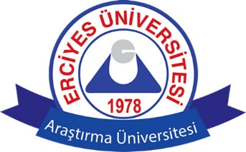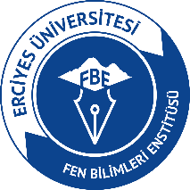
ERCİYES UNIVERSITY
GRADUATED SCHOOL OF NATURAL AND APPLIED SCIENCES
APPLICATION FORM FOR INTERNATIONAL CANDIDATE
PHOTO
Applicant Candidate’s
Passport Number/
TC ID Number
Name and Surname
Birth Place and Date |  | ..../..../.......
Graduated University/Faculty/Department

Applied
Department
Program | Master/Turkish Master/English
 | PhD/Turkish PhD/English

Applicant Candidate’s
Undergraduate Graduation Average
Master Graduation Average (If Available)
Turkish Language Score (If Available)
English Language Score and Exam Type | Score: | YDS YÖKDİL  IELTS TOEFL  DİĞER ………………….
Phone Number
e-mail
Adress

I confirm that the information I provided above is correct.

Name Surname Signature
Candidate
APPLICATION DOCUMENTS FOR INTERNATIONAL STUDENTS
1. Application form.
2. The approved photocopy of valid Passport
3. The approved photocopy of Diploma or Graduation Certificate
4. The approved photocopy of transcripts. The transcript that shows the courses taken and the grades achieved must be submitted. PhD program applicants must submit both their graduate and undergraduate transcripts. For admission to a Master of Science program, applicants must have graduated from an undergraduate program. The average should be at least 2 out of 4. For admission to a PhD program, applicants must have Master of Science certificate. The average should be at least 2,5 out of 4.
5. For the candidates applying for the graduate programs, the Foreign Language Exam Result Document of YDS, e- YDS, YÖKDİL or TOELF (or equivalence), which must be indicated at least 55 out of 100 for PhD. For English programs: the candidates must be obtained at least 70 out of 100 for a master of science program, at least 80 out of 100 for a PhD program, from a foreign language exam of YDS, e- YDS, YÖKDİL or TOELF (or equivalence).
6. For Turkish programs, the proficiency certificate of Turkish must be obtained from ERSEM/TÖMER (or equivalence) indicating at least C1 grade level certificate. But, for foreign students who have completed the undergraduate / graduate education in Turkey is not required.
7. Recognition certificate must be obtained from the Council of Higher Education (YÖK) in Ankara.
8. Curriculum Vitae (It must be written in English)

