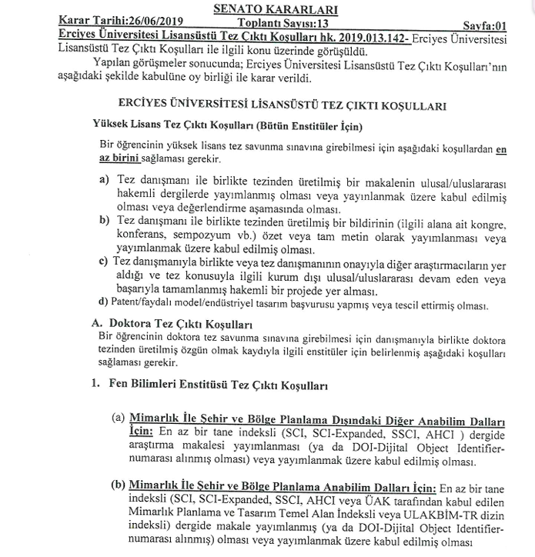

**10/08/2023 TARİH VE 27 SAYILI SENATO KARARI İLE REVİZE EDİLDİ.**

